|  |  |  |  |  |
| --- | --- | --- | --- | --- |
| Table 1: Major groups of metazoan taxa and their habitat (endoparasitic or ectoparasitic) and the number of parasitic species within these taxa present in online datasets WoRMS and GBIF Taxonomy Backbone. (updated and adapted from Poulin and Morand, 2004; Rohde, 2005; Blaxter and Koutsovoulos, 2014; Costello, 2016; Weinstein and Kuris, 2016). | |  | Minimum Number of | |
| *Marine Parasitic Taxa* | |  | Parasitic Habitat | Parasitic Species |
| Phylum Arthropoda |  | |  |  |
| Class Arachnida | Ixodida, Mesostigmata, Sarcoptiformes, Trombidiformes | | ecto | 1044 |
| Class Hexanauplia |  | |  |  |
| SubClass Copepoda | Monstrilloida, Siphonostomatoida | | ecto | 2122 |
| SubClass Thecostraca | Ascothoracida, Cirripedia (Rhizocephala, Thoracica) | | ecto | 416 |
| Class Ichthyostraca | Branchiura, Pentastomida | | ecto/endo | 255 |
| Class Insecta | Phthiraptera, Siphonaptera | | ecto | 3071 |
| Class Malacostraca |  | |  |  |
| Order Amphipoda | Hyperiidea, Cyamidae | | ecto | 317 |
| Order Isopoda | Cymothooidea, Cryptoniscoidea, Bopyroidea | | ecto | 2155 |
| Phylum Mollusca |  | |  |  |
| Class Gastropoda | Triviidae, Ovulidae, Eulimidae, Epitoniidae, Pyramidellidae, Architectonicidae, Cypraeidae | | ecto/endo | 3641 |
| Phylum Acanthocephala |  | | endo | 686 |
| Phylum Annelida | Hirudinea | | ecto | 198 |
| Phylum Nematoda | Chromadoria (Rhabditida, Monhysterida),  Enoplea (Dioctophymatida, Enoplida, Trichinellida) | | endo | 4142 |
| Phylum Platyhelminthes |  | |  |  |
| SubPhylum Neodermata |  | |  |  |
| Class Cestoda |  | | endo | 1904 |
| Class Monogenea |  | | ecto | 3644 |
| Class Trematoda |  | | endo | 5996 |
| Phylum Chordata | Echeliophis, Petromyzontiformes, Simenchelys | | ecto/endo | 46 |
| Phylum Tardigrada | *Tetrakentron* *synaptae*, *Pleocola* *limnoriae*, *Echiniscoides* *hoepneri* | | endo | 3 |
| Phylum Cnidaria | Myxozoa | | endo | 655 |
| Phylum Dicymida |  | | endo | 122 |
| Phylum Orthonectida |  | | endo | 26 |
|  |  | |  |  |
| ***TOTAL*** |  | |  | 27 699 |
| 1 lice parasitizing marine birds | | | | |

Figure 1: Major groups of marine metazoan taxa and the percentage of parasitic species within these taxa present in online dataset WoRMS. (updated and adapted from Poulin and Morand, 2004; Rohde, 2005; Blaxter and Koutsovoulos, 2014; Costello, 2016; Weinstein and Kuris, 2016).

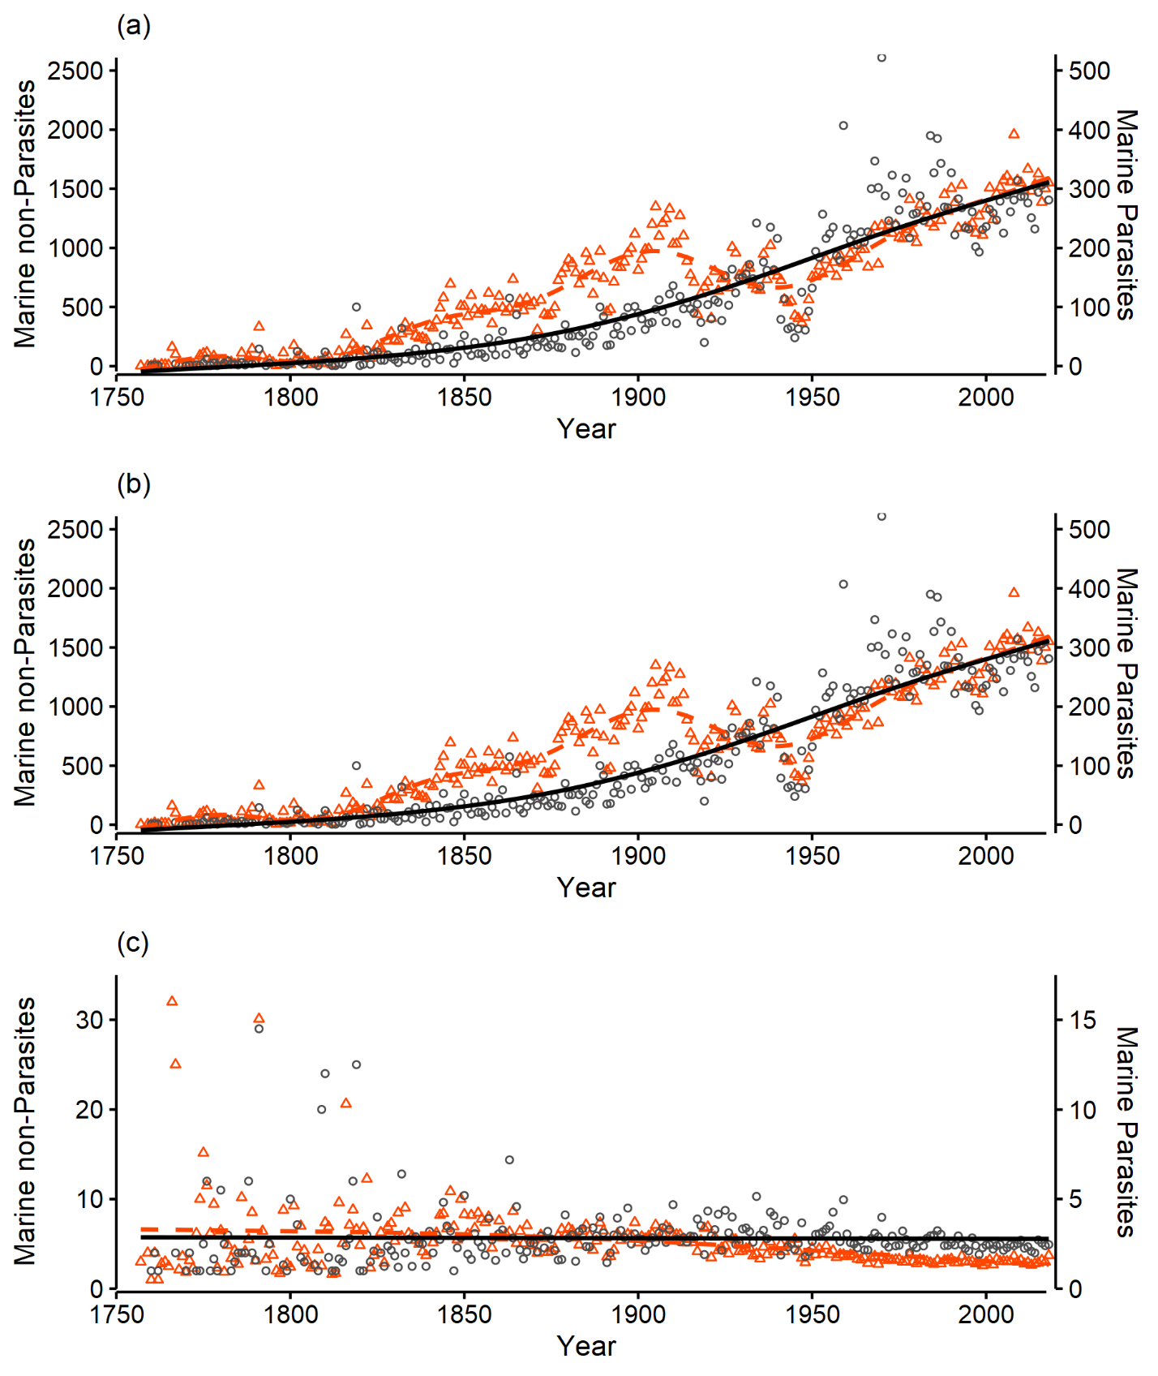Figure 2: The (a) number of species descriptions per year, (b) number of first authors per species description per year, and (c) total number of species descriptions divided by total number of first authors per description for parasites (solid line, circles, right axis, black) and non-parasites (dashed line, triangles, left axis, red), per year. Lines indicate ARIMA models.

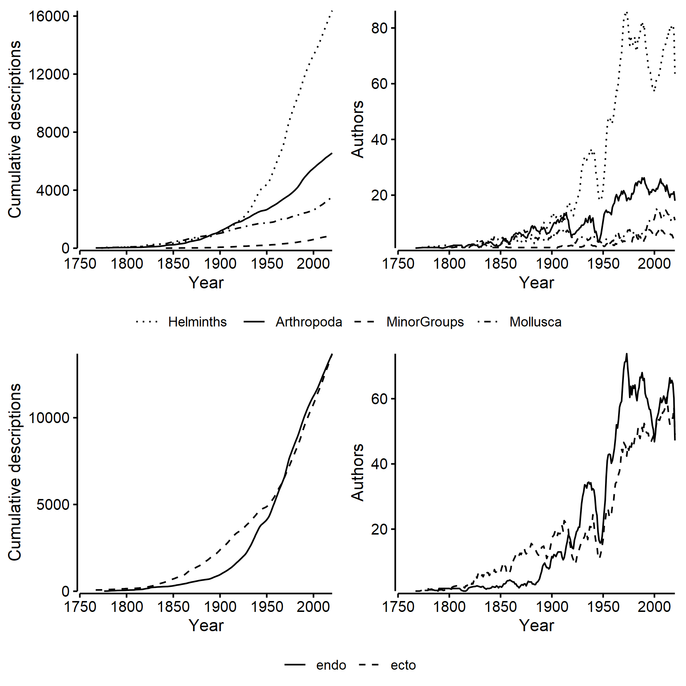

Figure 3: Cumulative descriptions (left column) and first authors (right column) of marine parasite species by taxonomic groups (top row) and habitat (bottom row). Lines are 5 year moving averages.

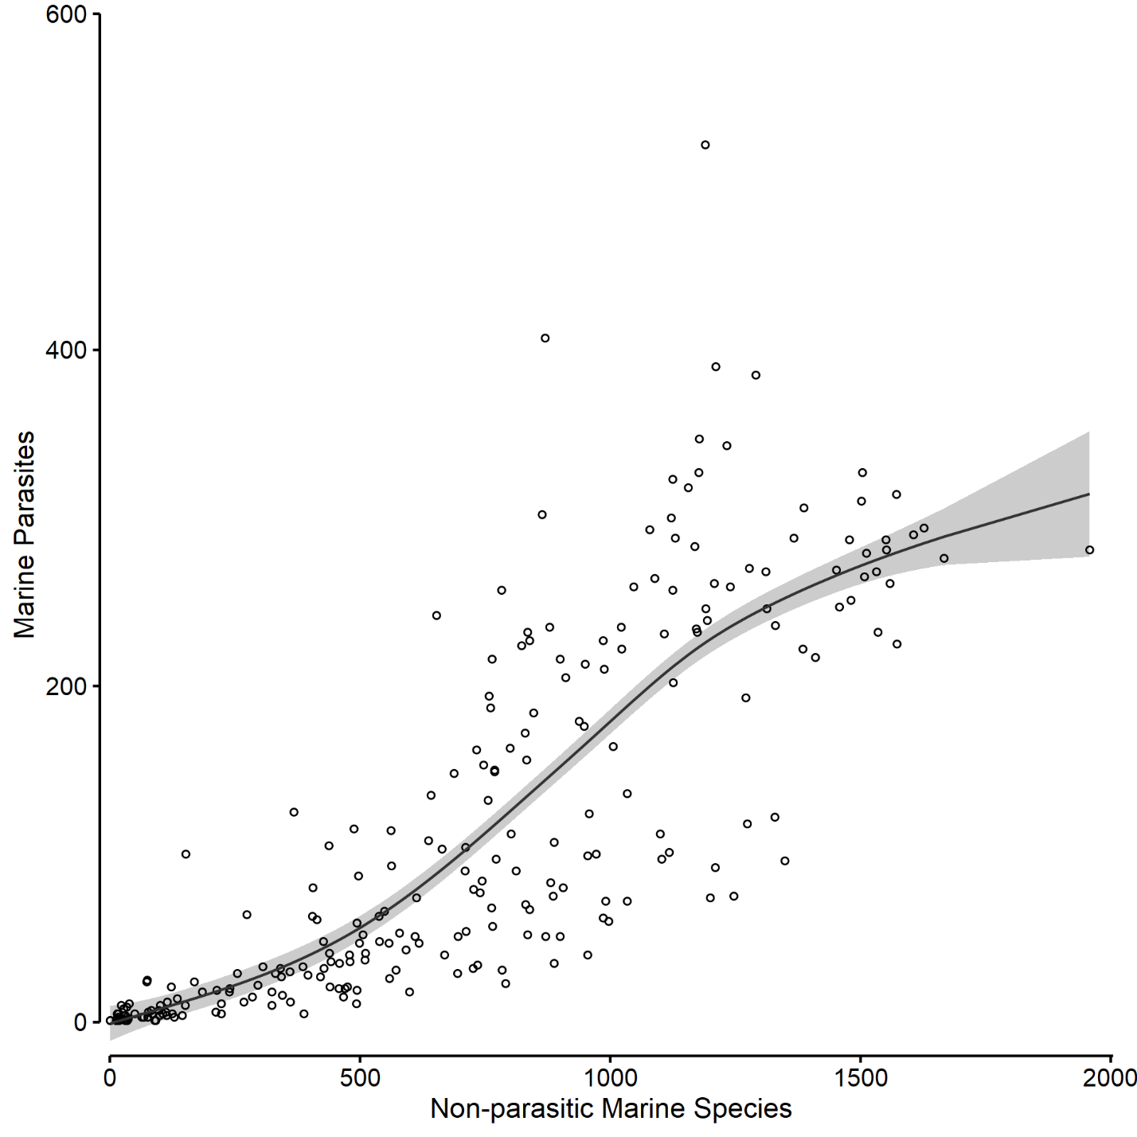

Figure 4: Relationship of the number of marine parasites to non-parasitic marine species described per year as a Generalized Additive Model (solid line). REML = 967.16, Deviance explained = 70 %, Adjusted r^2 = 0.695 with shaded 95% confidence interval.

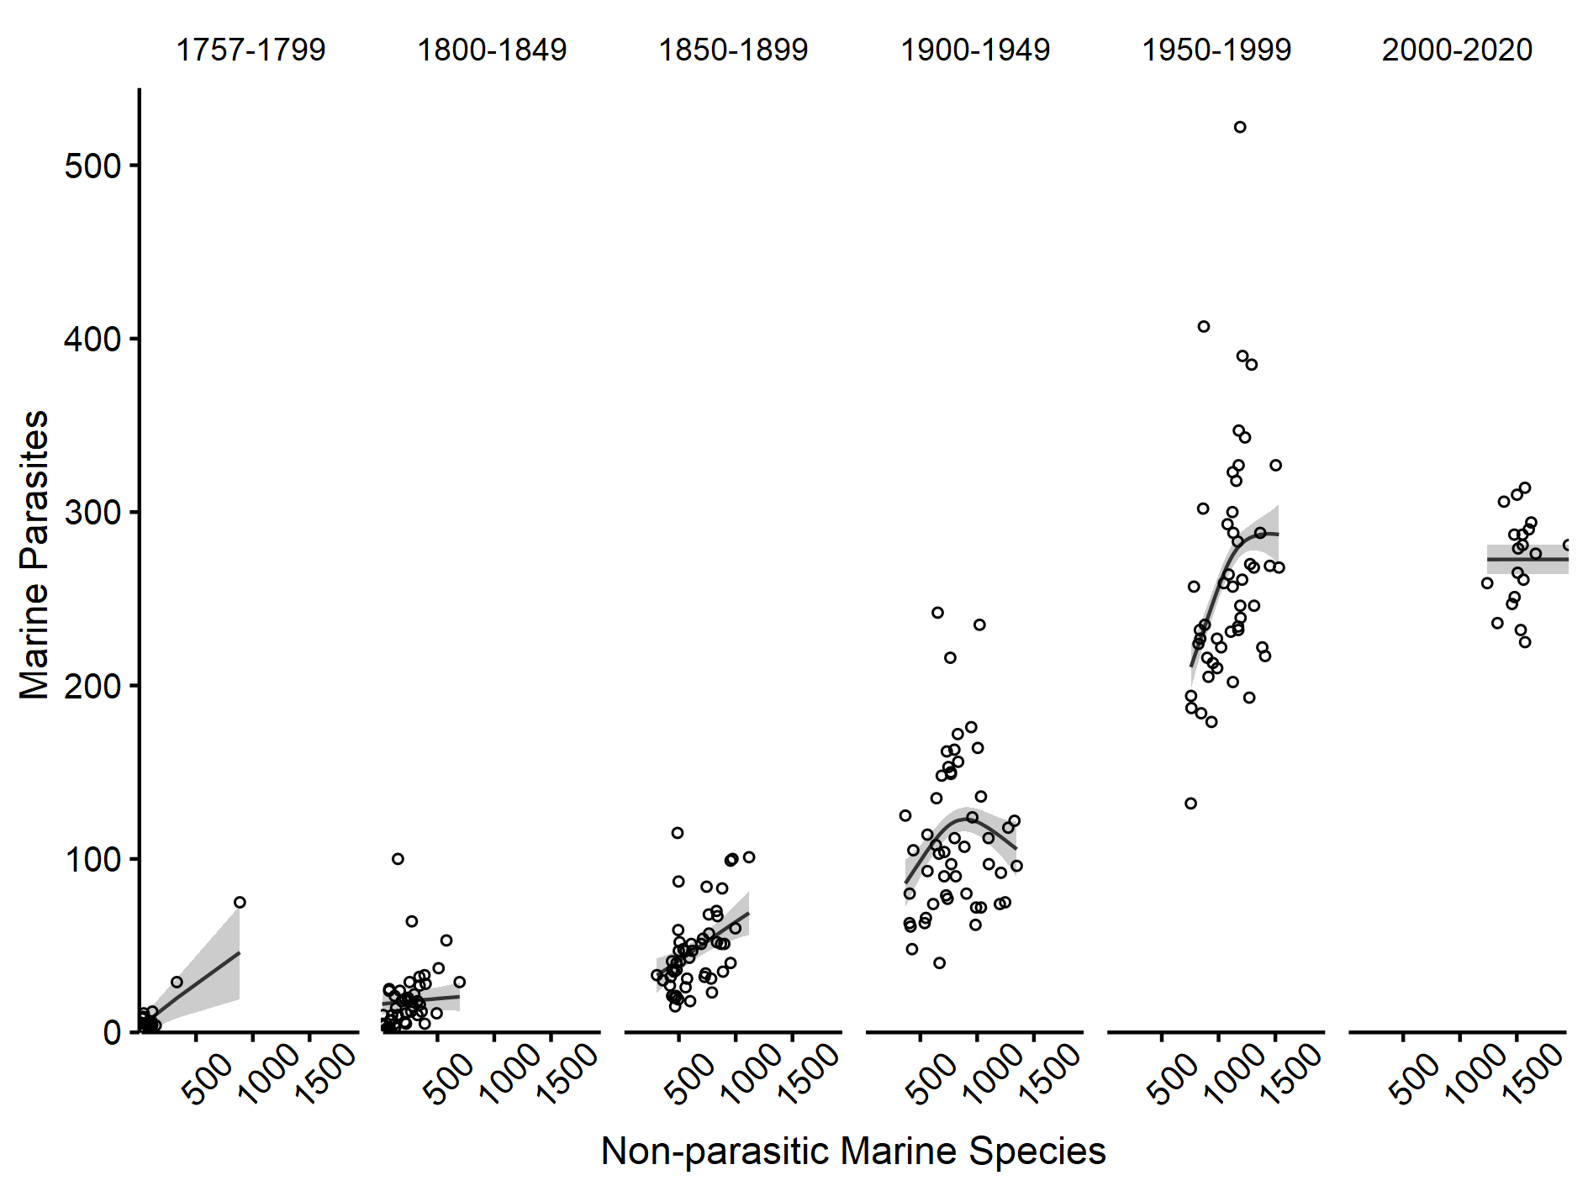

Figure 5: Relationship of marine parasites to non-parasitic marine species across half century time periods from 1756 to 2020. Shaded grey areas are 95% confidence intervals. REML = 876.02, Deviance explained = 88.9%, Adjusted r^2 = 0.884.